**OS experiment no. 09**

**Name :** Devansh Shah

**Roll No:** 1914078

**Batch :** B1

**Exp No:** 09

**Date: 28th November 2021**

**Q1.** Implement any one disk scheduling algorithm.

**The method chosen over here is the SSTF algorithm.**

**SSTF:** In SSTF (Shortest Seek Time First), requests having shortest seek time are executed first. So, the seek time of every request is calculated in advance in the queue and then they are scheduled according to their calculated seek time. As a result, the request near the disk arm will get executed first. SSTF is certainly an improvement over FCFS as it decreases the average response time and increases the throughput of system.

**CODE:**

oor = [int(i) for i in input('Enter space seperated order of request: ').split()]

currpos = int(input('Enter current position of READ/WRITE head: '))

oor.sort()

st = 0

while(len(oor) != 0):

    min = 99999

    minnum = 0

    for i in oor:

        if abs(i - currpos) < min:

            min = abs(i - currpos)

            minnum = i

    currpos = minnum

    oor.remove(minnum)

    st += min

print('Total seek time =', st)

**OUTPUT:**

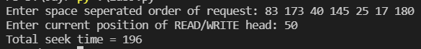

**Outcome:** CO2: Demonstrate use of inter process communication.

**Conclusion:** We successfully executed and desired results were obtained from SSTF disk scheduling algorithm